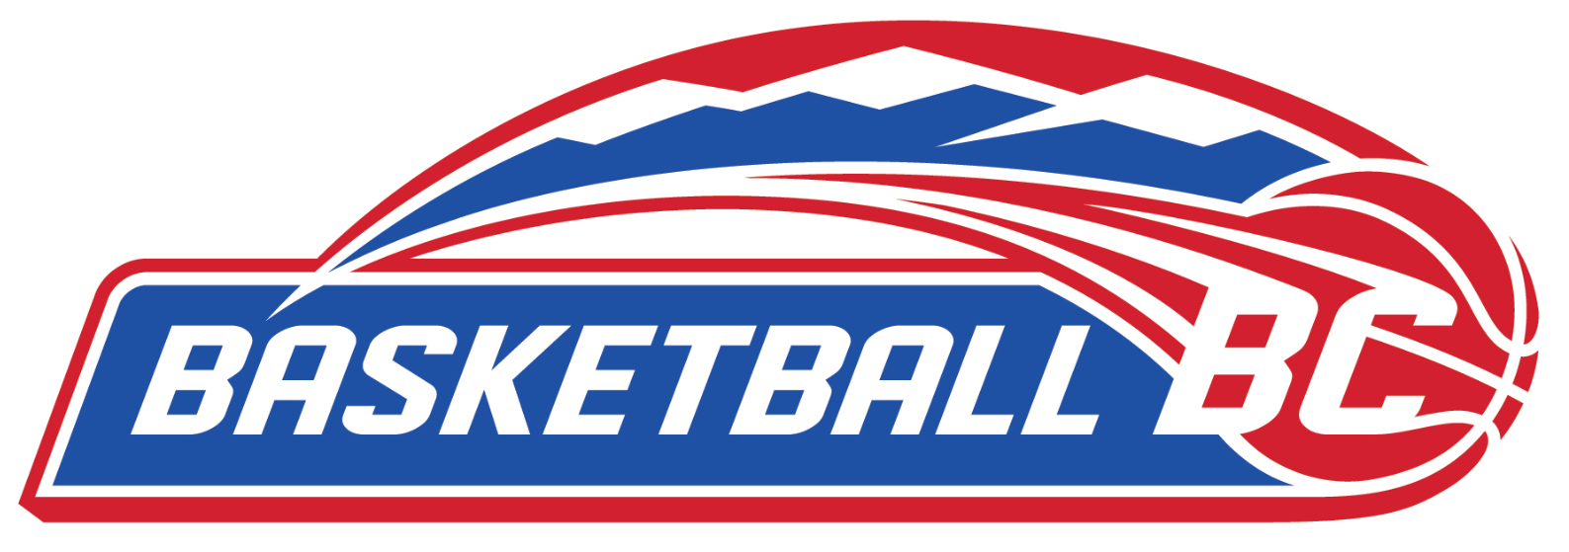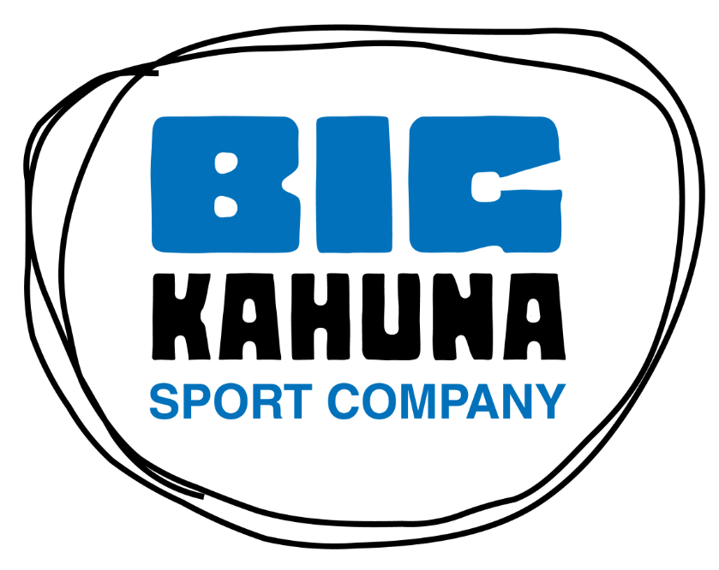

FOR IMMEDIATE RELEASE: 3/13/17
BASKETBALL BC, UNDER ARMOUR CANADA AND BIG KAHUNA SPORT CO. FORM A STRATEGIC PARTNERSHIP!
LANGLEY, BC:

Basketball BC, Under Armour Canada and Big Kahuna Sport Co. are excited to announce a new partnership!

Some of the highlights of the partnership will be:
- Big Kahuna to be the official supplier to Basketball BC with specific attention to providing Under Armour gear to the High-Performance program including Provincial Teams, POD athletes and coaches and regular staff/Board clothing
- Big Kahuna to cooperate and assist Basketball BC with design and production details
- Big Kahuna to offer benefits to Basketball BC members through online promotions

Basketball BC to use the services of Big Kahuna for all product other than programs that are presently serviced by existing suppliers. Basketball BC to give first rights to Big Kahuna for any new programs or renewals of existing programs where applicable

Big Kahuna and Basketball BC will release an updated Basketball BC logo to be part of all gear and branding going forward.

Lawrie Johns, Basketball BC Executive Director enthusiastically noted,” Our partnership with Big Kahuna and through them with Under Armour represents a further indication of servicing athletes and programs with a high profile supplier. UA is recognized as a leading brand in uniform and equipment supplies and is particularly active with well-known basketball programs and individuals. We know this will be very appealing to our high-performance athletes as well as those striving to be part of our programs. Seeing our Provincial Teams in state of the art unis at Nationals, USA tournaments and at the Canada Games in Winnipeg is something I very much look forward to. Big Kahuna offers us a professional and well respected local contact and working even closer with them will be exciting.”

Craig Preece, President of Big Kahuna, added, “Basketball BC is an extremely well run Organization with a renewed focus on their branding. Under Armour, as a growing global basketball brand, fits in perfectly with their vision. We are very excited about this strategic partnership and our position as Basketball BC’s Service Provider.”

About Basketball BC
Basketball BC creates, guides and supports programs that build and protect the integrity of the game of basketball for all participants based on the Canadian Sport for Life Pathway (CS4L).

We are committed to growing the game by involving players at all stages of development, coaches at the community and institutional level, assisting in the development of officials and sustaining partnerships to assist in the provision of opportunities and developing an infrastructure that supports our game.

Our values of accessibility, respect, excellence, celebration of people and transparency will be cornerstones of our activity.

Our mission continues to be to develop a lifelong passion for our sport and grow the great game throughout the province.

About Under Armour, Inc.
Under Armour, the originator of performance footwear, apparel and equipment, revolutionized how athletes across the world dress. Designed to make all athletes better, the brand's innovative products are sold worldwide to athletes at all levels. The Under Armour Connected Fitness™ platform powers the world's largest digital health and fitness community through a suite of applications: UA Record, MapMyFitness, Endomondo and MyFitnessPal. The Under Armour global headquarters is in Baltimore, Maryland. For further information, please visit the Company's website at www.uabiz.com.

Under Armour has two classes of publicly traded common stock listed on the New York Stock Exchange: Class C stock trades under the ticker symbol “UA” and Class A stock trades under the ticker symbol “UAA”. For more information about Under Armour’s stock, please visit the Company’s Investor Relations website at http://www.uabiz.com/investors.cfm.

About Big Kahuna
Founded in 1998 and based in Surrey, BC, Big Kahuna Sport Co. is a full service TEAM Dealer providing customized solutions for Apparel, Accessories and Equipment. Big Kahuna markets and sells their products vis their direct TEAM Sales force to Customers from Coast to Coast.

Big Kahuna’s vision is to make their name synonymous with excellence in the Canadian Team Sport market by creating a “think big: culture with an unwavering attitude towards complete Customer satisfaction and experience.

Big Kahuna’s Mission is the Think big, Service Bigger. For more information about Big Kahuna Sport Co., please visit www.bigkahuna.ca

